WELCOME!

We’re so excited that you are here for the Healthy Church Growth Conference.
You are about to join an alumni group of millions of pastors and church leaders from all around the world who have taken this training. What is the The Secret behind all we do?

“Christ in you…” Colossians 1:27

Jesus “And Jesus answered them, “Truly, I say to you, if you have faith and do not doubt, you will not only do what has been done to the fig tree, but even if you say to this mountain, ‘Be taken up and thrown into the sea,’ it will happen. And whatever you ask in prayer, you will receive, if you have faith.” Matthew 21:21-22

It is my prayer that God will use you to fulfill His purposes here at Everywhere Church and around the world.

SEMINAR GOALS

• TO STIMULATE YOUR CREATIVITY
We’re going to hit you with a ton of ideas.
Then you’ll think up more on your own!

"The intelligent man is always open to new ideas.
In fact, he looks for them!" Proverbs 18:15 (LB)

• TO SHARPEN YOUR SKILLS

Periodically we all need to be challenged!

"If the ax is dull and its edge is unsharpened, more strength is needed. But skill will bring success." Ecclesiastes 10:10

• TO ENCOURAGE YOU PERSONALLY

The ministry is often difficult and thankless.
We want to affirm and support you.

“Let us not get tired of doing what is right, for after a while we will reap a harvest of blessing if we don't get discouraged and give up.” Galatians 6:9 (LB)

Thank you for your willingness to be equipped and obey Jesus. My prayer is that each of you will be more effective servants of Christ as a result of this seminar.

Warmly,

Jimmie Davidson
Founding-Lead Pastor, Everywhere Church

“By the grace of God, I laid a foundation as an expert builder...But each one should be careful how he builds. .for his work will be shown for what it is...the fire will test the quality of each man’s work. If what he has built survives, he will receive his reward.” 1 Corinthians 3:10-14

(ALL SCRIPTURE VERSES FROM THE NEW INTERNATIONAL VERSION UNLESS OTHERWISE NOTED.)
THE ASSUMPTIONS THAT THIS SEMINAR IS BASED ON

1. There is no correlation between the size and strength of a church.

2. There is more than one way to grow a church. So we never criticize what God is blessing.

3. It takes all kinds of churches to reach all kinds of people.

4. If a principle is biblical, it will work anywhere.

5. Never confuse the method with the message. The message must never change, but the methods must change.

BUILDING A HEALTHY CHURCH
Establishing A Foundation For Growth

Too often we ask the wrong question when it comes to our churches. We ask “What will make my church grow?” That is the wrong question.

THE RIGHT QUESTION: What is ________________ my church from growing?

Growth comes from ________________.

Health comes from __________________.

Every church is directed by some force....

...By tradition

...By personalities

...By finances

...By buildings

...By programs

...By events

...By the unchurched

A Biblical Alternative: Become a _______________ church empowered by Jesus!

Jesus said, “...I will build my church, and the gates of Hell will not overcome it!” Matthew 16:18

“Many are the plans in a man’s heart, but it is the Lord’s purpose that prevails.”
Proverbs 19:21

“By the grace of God, I laid a foundation as an expert builder. .But each one should be careful how he builds...for his work will be shown for what it is. The fire will test the quality of each man’s work. If what he has built survives, he will receive his reward.”
1 Corinthians 3:10-14

I. DEFINING WHAT JESUS COMMANDED HIS CHURCH TO DO

Why is it important?

1. IT BUILDS ___________________________

“Let there be real harmony so there won’t be any splits in the church...Be of one mind, united in thought and purpose.” 1 Corinthians 1:10 (LB)

“Where there is no vision, the people perish.” Proverbs 29:18 (KJV)

2. IT REDUCES ________________________

“You Lord, give perfect peace to those who keep their purpose firm...” Isaiah 26:3 (GN)

“The double-minded man can never keep a steady course.” James 1:8 (NEB)

“I’ve labored to no purpose. I’ve spent my strength in vain and for nothing.” Isaiah 49:4

3. IT ALLOWS __________________________

(Paul) “I am bringing all my energies to bear on this one thing: forgetting the past and looking forward to what lies ahead.” Philippians 3:13 (LB)

Efficiency: “Doing things right”

Effectiveness: “Doing the right things”

4. IT ATTRACTS _____________________________

“Tell us how to proceed in setting things straight, and we will fully cooperate.” Ezra 10:4 (LB)

“You have helped me in the work of the gospel...” Philippians 1:5 (GN)

“If your goals are good, you will be respected.” Proverbs 11:27 (GN)

5. IT ASSISTS ___________________________

“Examine yourselves to see whether you are in the faith; test yourselves.” 2 Corinthians 13:5

HOW TO DEFINE JESUS PURPOSES FOR YOUR CHURCH

1. Lead your members in a study of the biblical passages about the church:

- Christ’s ministry on earth

- The images of the church

- The New Testament churches

- The commands of Christ

Verses That Relate To The Purposes Of The Church

Matt. 5:13-16 John 13:34-35 Eph. 2:19-22
Matt. 9:35 John 20:21 Eph. 3:6, 14-21
Matt. 11:28-30 Acts 1:8 Eph. 4:11-16
Matt. 16:15-19 Acts 2:41-47 Eph. 5:23-24
Matt. 18:19-20 Acts 4:32-35 Col. 1:24
Matt. 22:36-40 Acts 5:42 Col. 3:15-16
Matt. 24:14 Acts 6:1-7 1 Thess. 1:3
Matt. 25:34-40 Rom. 12:1-8 1 Thess. 5:11
Matt. 28:18-20 Rom. 15:1-7 Heb. 10:24-25
Mark 10:43-45 1 Cor. 12:12-31 Heb. 13:7,17
Luke 4:18-19 2 Cor. 5:17-6:1 1 Peter 2:9-10
Luke 4:43-44 Gal. 5:13-15 1 John 1:5-7
John 4:23 Gal. 6:1-2 1 John 4:7-21
John 10:14-18 Eph. 1:22-23

2. Ask 2 questions:

- What are we to ________________

- What are we to ________________

BODY, FLOCK, FAMILY, CHURCH

3. Write out some paragraphs that say all you think needs to be said.
Then edit out the unnecessary words.

4. Summarize your answers in a sentence.

4 Characteristics Of A Good Purpose Statement:

1. BIBLICAL

2. SPECIFIC

3. TRANSFERABLE

4. MEASURABLE

HEALTHY CHURCH IN A SENTENCE

“A GREAT COMMITMENT
TO THE GREAT COMMANDMENT
AND THE GREAT COMMISSION
WILL GROW A GREAT CHURCH!”

THE PURPOSES OF THE CHURCH COME FROM TWO COMMANDS JESUS GAVE.

THE GREAT COMMANDMENT

“LOVE THE LORD YOUR GOD with all your heart...soul...and mind. This is the first and greatest commandment. And the second is like it: LOVE YOUR NEIGHBOR as yourself. All the Law and Prophets hang on these two commandments.” Matthew 22:36-40

THE GREAT COMMISSION

“GO AND MAKE DISCIPLES of all nations, BAPTIZING THEM in the name of the Father and of the Son and of the Holy Spirit, and TEACHING THEM TO DO everything I have commanded you.” Matthew 28:19-20

Five Instructions For The Church

1. “Love God with all your heart” ________________

2. “Love your neighbor as yourself” ________________

3. “Go...make disciples” ________________

4. “Baptizing them” ________________

5. “Teaching them to do” ________________

Jesus’ ministry modeled these 5 purposes: John 17:1-26

Vs. 4 “I have brought you glory on earth.” (WORSHIP)
Vs. 6 “I revealed you to those whom you gave me out of the world.” (EVANGELISM)
Vs. 8 “I gave them the words you gave me.” (DISCIPLESHIP)
Vs.12 “While I was with them, I protected them and kept them safe.” (FELLOWSHIP)
Vs.18 “As you sent me into the world, I have sent them into the world.” (MINISTRY)

The first church fulfilled these 5 purposes: Acts 2:41-47

“Those who accepted his message were baptized...They devoted themselves to the apostles’ teaching and to the fellowship, to the breaking of bread and to prayer...All the believers were together ...they gave to anyone as he had need... Every day they continued to meet together in the temple courts. They broke bread in their homes and ate together with glad and sincere hearts, praising God... And the Lord added to their number daily those who were being saved.”

Paul explained these 5 purposes: Ephesians 4:11-16

“God gave some to be apostles, some to be prophets, some to be evangelists, and some to be pastors and teachers, to prepare God’s people for works of ministry, so that the body of Christ may be built up until we all reach unity in the faith and in the knowledge of the Son of God and become mature, attaining to the whole measure of the fullness of Christ...From Him the whole body, joined and held together by every supporting ligament, grows and builds itself up in love, as each part does its work.”

THE CHURCH EXISTS TO:

1. Celebrate God’s _______________________ (Worship)
“Exalt our Master”

“O magnify the Lord with me and let us exalt his name together.” Psalm 34:3 (RSV)

“I was glad when they said to me, ‘Let us go to the Lord’s house.’” Psalm 122:1 (GN)

2. Communicate God’s __________________________(Evangelism)
“Evangelize our mission field”

“The most important thing is that I complete my mission - the work the Lord gave me to do - to tell people the Good News about God’s grace.” Acts 20:24 (NCV)

“You will be my witnesses...” Acts 1:8

3. Incorporate God’s _________________________ (Fellowship)
“Encourage our members”

“You are a member of God’s very own family and you belong in God’s household with every other Christian.” Ephesians 2:19 (LB)

4. Educate God’s ________________ (Discipleship)
“Educate for maturity”

“...building up the church, the body of Christ, to a position of strength and maturity...until all become full grown in the Lord.”
Ephesians 4:12b-13 (LB)

5. Demonstrate God’s _________________________ (Ministry)
“Equip for ministry”

“...to prepare God’s people for the work of ministry.” Ephesians 4:12a

EVERYWHERE CHURCH PURPOSE STATEMENT

To Bring them into the fellowship/membership of God’s family, to build them up to Christ like Maturity, To train them for their Ministry in the church, To send them out for their Mission in the world, all to Magnify Christ’s name for the global glory of God!

What makes an effective purpose statement?

1. It is stated in terms of results (fruit), rather than activities.

Our Business: Developing Christ centered lives for God’s glory. (Ephesians 4:11-16)

Our Product: Changed lives.

2. It is stated in a way that encourages participation by every member.

3. The purposes are arranged into a sequential process.

“Bring them in...Build them up...Train them for...Send them out!”

II. COMMUNICATING WHAT JESUS COMMANDED

It’s not enough to simply define what Jesus said!

The #1 task of leadership is to continually clarify and communicate the purpose of His church.

5 Ways to Communicate Vision and Purpose

1. ________________

2. ________________

3. ________________

4. ________________

5. ________________

Some of the ways we’ve communicated our purposes at Everywhere Church:

- Web Site
- Purpose Seminars
- Messages
- Series
- Social Media
- Podcasts
- Host Homes

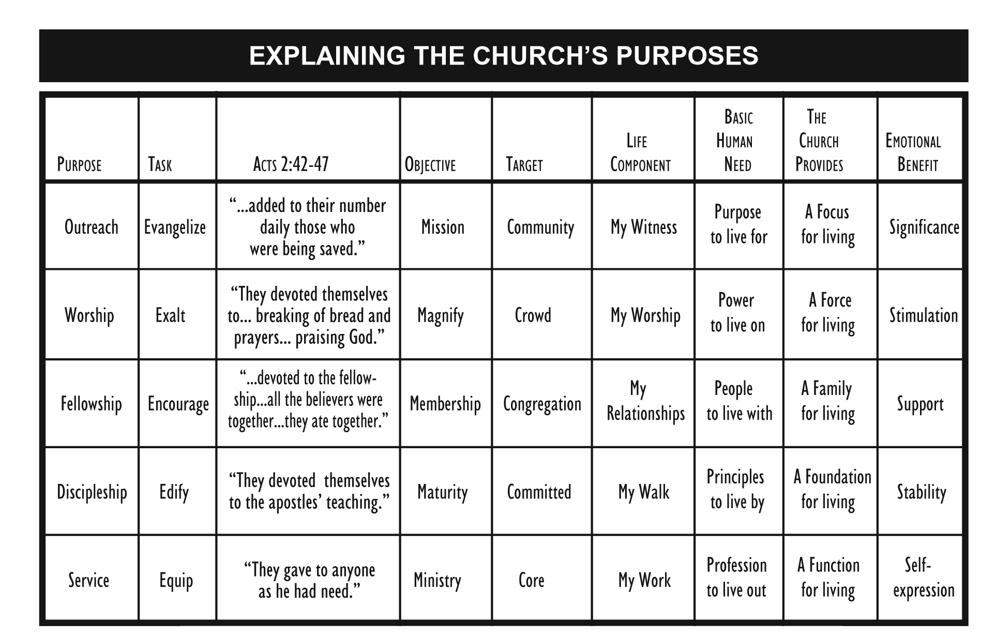

Don’t be afraid to repeat yourself. Nobody gets it the first time.

Say it over and over - in fresh ways. Practice “creative redundancy!”

III. APPLYING YOUR PURPOSES

It’s not enough to just define and communicate your purposes.

You must apply the purposes to every area of your church’s life.

The key to application is ____________________

NOTE! Unless you set up an intentional plan to balance the five purposes, your church will tend to overemphasize the purpose that ________________ is most passionate about.

Only a Healthy Church strategy and structure can maintain balance.

HOW TO FOCUS ON WHAT JESUS TELLS US TO DO
Begin to see WHERE people are in their relationship with Christ and ministry to them.

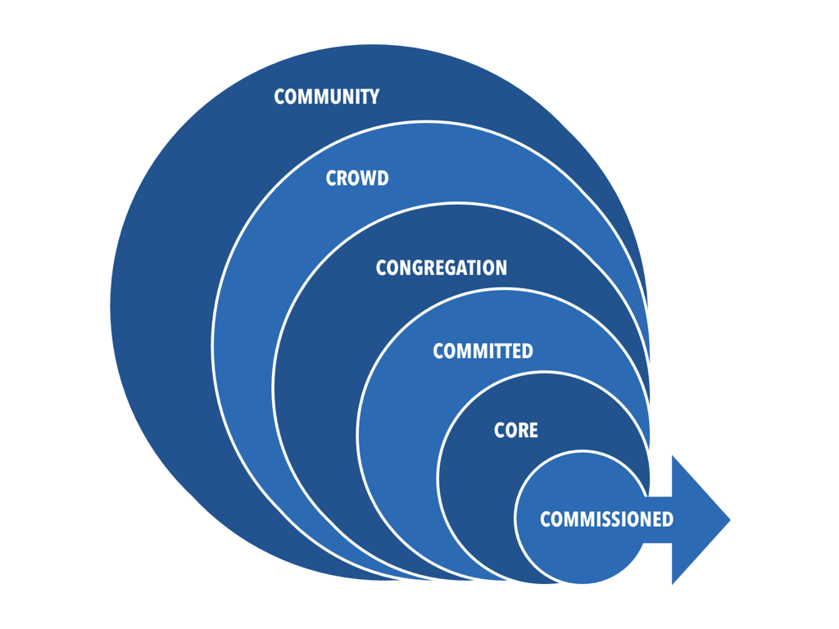

LEVELS OF COMMITMENT

Your Church Statistics

Target Group Number in Group

“The Commissioned” – those committed to Magnify. _______________

“The Core” - those active in Ministry ________________

“The Committed” - those committed to Maturity ________________

“The Congregation” - those committed to Membership ________________

“The Crowd” - the regular attenders at Worship ________________

“The Community” - the Mission field ________________
(Occasional Attenders 4x a year)

TEN WAYS TO BE A HEALTHY CHURCH ALIGNED AROUND JESUS

1. ASSIMILATE NEW MEMBERS SEEING JESUS AS OUR MODEL

Grow the church from the outside in, rather than from the inside out!

Matthew 9: The example of Matthew: He witnessed Jesus doing all of these.

2. PROGRAM AROUND JESUS COMMANDS

Design or choose a program to fulfill each of HIS purposes. Jesus did different things with different people depending on where they were.

3. EDUCATE YOUR PEOPLE ON WHAT JESUS COMMANDED

Build your Christian Education ministry around HIS PURPOSES.

Everywhere Church Life Development Pathway Purpose Seminars

(Note: Please change the title of the classes below to Purpose 1 Seminar, Purpose 2 Etc.)

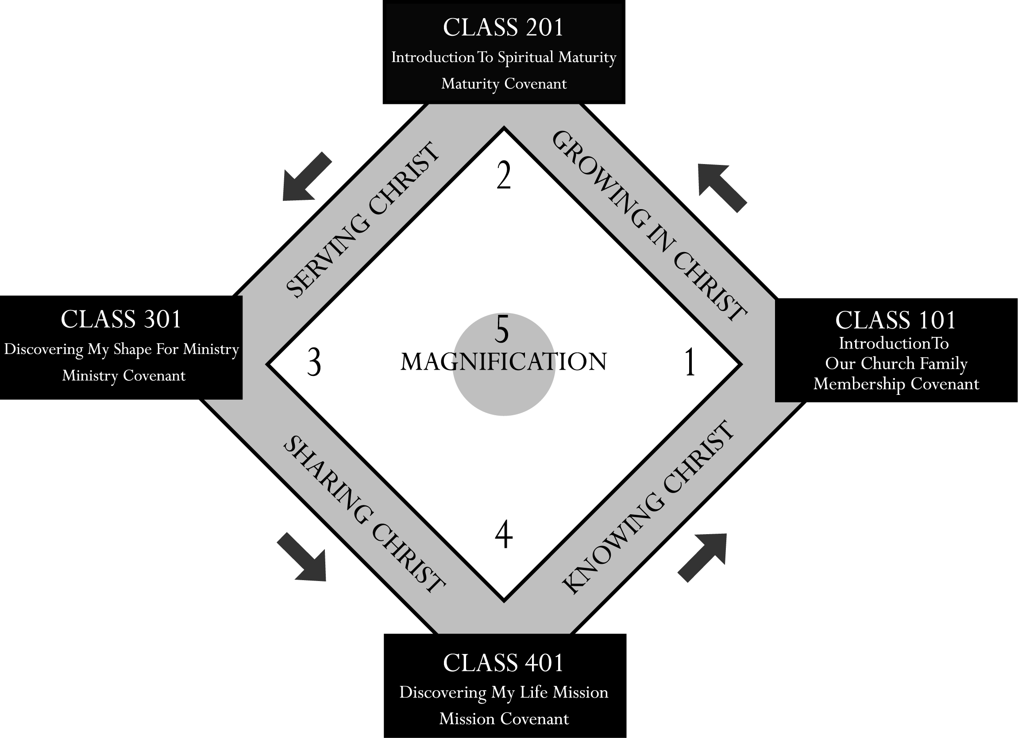

Christian Life and Service Seminars
100 Level Seminars: To lead people to Christ and membership at Everywhere Church
200 Level Seminars: To grow people to spiritual maturity
300 Level Seminars: To equip people with the skills they need for ministry
400 Level Seminars: To enlist people to the worldwide mission of sharing Christ
500 Level Seminars: To Magnify Christ For The Global Glory of God.

4. FORM E-GROUPS, HOST HOMES, SMALL GROUPS ON PURPOSE. Acts 2:42-47

- Place the Healthy Church diamond and circle in the heart of every HOST HOME!

- Find a group member to champion each of the five purposes.

5. ADD STAFF ON PURPOSE

Director\Pastor of Membership
Director\Pastor of Maturity
Director\Pastor of Ministries
Director\Pastor of Mission
Director\Pastor of Magnification-Music

Any church can be Healthy, regardless of size.

Start with volunteers. Romans 12

6. STRUCTURE BASED ON JESUS COMMANDS.

Organize your staff & lay leaders into PURPOSE teams with a clearly defined task and FOCUS.

TEAMS TASK & TARGET

The MISSION Team Evangelize the Community
The MAGNIFICATION Team Exalt Christ Globally
The MEMBERSHIP Team Encourage the Congregation
The MATURITY Team Educate the Committed
The MINISTRY Team Equip the Core
LIFE DEVELOPMENT Team Fulfill the purposes with children & youth
ADMINISTRATION Team Support the other teams

7. PREACH ON JESUS COMMANDS.

Teach the people to act on what Jesus says with a Balanced your preaching plan with at least one series related to each of the five purposes.

Examples of some series from Pastor Rick: Pastors.com

“You Are Shaped For Significance” (a ministry series)
“The Six Phases of Faith” (a maturity series)
“Learning To Hear God’s Voice” (a worship series)
“Building Great Relationships” (a series to deepen our fellowship)
“Answering Life’s Toughest Questions” (an evangelistic series)

8. BUDGET FOR EACH PURPOSE BASED ON HIS RESOURCES NOT YOURS.

FAITH BUDGET

Categorize every line item in your budget by the purpose that it relates to.

“Without Faith it’s impossible to please God.” Hebrews 11:6

9. CALENDAR ON PURPOSE

Designate two months of each year to give special emphasis to each purpose.

Each Team is responsible for events and special programs during their months.

Big Days Move the Church Forward but without a discipleship process the back door is bigger than the front door and you never get traction.

10. EVALUATE AROUND JESUS COMMANDS EACH WEEK.

We use simple reports at Everywhere Church To give us a Snapshot of who’s on each base and how many are in each circle also including insight into what areas need attention.

- THIS IS WHAT I NOTICED FIRST_____________
THIS IS WHAT I LIKED BEST________________
THIS IS WHAT I LIKED LEAST _______________

- WEEKLY STAFF MEETING
WHAT’S RIGHT__________________________
WHATS MISSING ________________________
WHAT’S CONFUSED _____________________
WHAT’S WRONG_________________________
GAUGES: ATTENDANCE, BAPTISMS, SALVATIONS ETC

The Priorities of a Healthy Church

Priority #1: God’s Kingdom First

Priority #2: People

Priority #3: Programs

Priority #4: Places to Gather

BUILDING A HEALTHY CHURCH

PERSONAL APPLICATION WORK SHEET

1. In your opinion, what has been the driving force of your church?

2. Which of the 5 New Testament purposes has your church tended to emphasize the most?

3. Which of the 5 purposes has your church tended to emphasize least?

4. Which purpose do you feel most passionate about?

ANSWERS

THE RIGHT QUESTION: What is (KEEPING) my church from growing?

Growth comes from (HEALTH/ABIDING IN CHRIST)

A Biblical Alternative: Become a (HEALTHY CHURCH) that is empowered by Jesus!

- DEFINING WHAT JESUS COMMANDED HIS CHURCH TO DO.

Why is it important?

- IT BUILDS (MORALE)

2.IT REDUCES (FRUSTRATION)

3. IT ALLOWS (CONCENTRATION)

4. IT ATTRACTS (COOPERATION)

5. IT ASSISTS (EXAMINATION)

2. Ask 2 questions:

- What are we to (DO)

- What are we to (BE)

Five Instructions For The Church

1. “Love God with all your heart” (WORSHIP)

2. “Love your neighbor as yourself” (MINISTRY)

3. “Go...make disciples” (EVANGELISM)

4. “Baptizing them” (FELLOWSHIP)

5. “Teaching them to do” (DISCIPLESHIP)

THE CHURCH EXISTS TO:

1. Celebrate God’s (PRESENCE) (Worship)

2.Communicate God’s (WORD) (Evangelism)

3. Incorporate God’s (FAMILY) (Fellowship)

4. Educate God’s (PEOPLE) (Discipleship)

5. Demonstrate God’s (LOVE) (Ministry)

5 Ways to Communicate Vision and Purpose

1. slogans

Every leader understands the power of slogans, the things that people can remember. We’ve talked about that already.

2. symbols

3. sciptures

4. stories

5. specifics

The key to application is BALANCE

NOTE! Unless you set up an intentional plan to balance the five purposes, your church will tend to overemphasize the purpose that THE PASTOR is most passionate about.

ENGAGING YOUR COMMUNITY FOR EVANGELISM
Learning To Fish For Souls Like Jesus

“Jesus called out, ‘Come along with me and I will show you how to fish for the souls of men.’” Matthew 4:19 (LB)

JESUS’ STRATEGY OF FISHING FOR MEN
See Matthew 10 & Luke 10

I. KNOW WHAT YOU ARE _________________________

You must identify who you are trying to reach.

Jesus had a clear evangelistic FOCUS:
“I was sent only to the lost sheep of Israel.” Matthew 15:24

Paul had a clear evangelistic FOCUS:
“I was entrusted with the task of preaching the gospel to the Gentiles,
just as Peter had been given the task of preaching the gospel to the Jews.”
Galatians 2:7

Jesus gave the disciples a clear evangelistic FOCUS:
“Don’t go among the Gentiles or enter any town of the Samaritans.
Go rather to the lost sheep of Israel.” Matthew 10:5-6

HOW TO DEFINE YOUR FOCUS

1. DEFINE YOUR FOCUS GEOGRAPHICALLY

ASK: How many people live in this area?

2. DEFINE YOUR FOCUS DEMOGRAPHICALLY

ASK: What kind of people live in this area?

3. DEFINE YOUR FOCUS CULTURALLY

ASK: What are their values, interests and fears?

Best Source: Personal survey

4. DEFINE YOUR FOCUS SPIRITUALLY

ASK: What do they already know about the gospel?

Determine their religious background.

Fact: All unchurched are not alike!

Now Personalize Your FOCUS!

Develop a profile of your typical unchurched resident –
“EVERYWHERE ED”

"SADDLEBACK SAM" - OUR FOCUS
The Likely Mr. South Orange County



He is well educated • •

• He is skeptical of
"organized" religion

He likes his job •

• He is self-satisfied, even
smug, about his station
in life.
He likes where he •
lives

Health and fitness •
are high priorities for
himself and his family

He'd rather be in a •
large group than a
small one
• He prefers the casual and
informal over the formal

He is skeptical of •
"organized" religion

• He is over-extended in both time and money

Who is the target of your church?

II. LEARN TO ___________________________

“Jesus knew what they were thinking...”
Matthew 9:4, 12:25; Mark 2:8; Luke 5:22, 9:47, 11:17

“I am sending you out like sheep among wolves. Therefore, be as wise as serpents and as harmless as doves.” Matthew 10:16

“Be wise in the way you act toward those who are not believers...”
Colossians 4:5 (GN)

The problem: The longer I am a believer, ________________ I think like an unbeliever.

“Resistance” is often just poor communication.

How to discover the “mindset” of unbelievers: ______________________

If you don’t ask the right questions, you won’t get the right answers.

If you don’t get the right answers, you won’t develop the right strategy.

If you don’t develop the right strategy, you won’t get the right results.
ASK….

1. Are you currently active in a local church?
2. What do you feel is the greatest need in this area?
3. Why do you think most people don’t attend church?
4. If you were looking for a church, what kind of things would you look for?
5. What advice would you give me? How can I help you?

THE FOUR GREATEST COMPLAINTS IN OUR AREA

1. Sermons are boring and irrelevant.

2. Members are unfriendly to visitors.

3. Too much emphasis on money.

4. Poor childcare.

Our conclusion: Most unchurched people are not atheists.

They're just turned off and too busy!

SADDLEBACK’S FIRST LETTER TO THE COMMMUNITY

Hi Neighbor! March 20, 1980

AT LAST!
A NEW CHURCH FOR THOSE WHO HAVE GIVEN UP ON TRADITIONAL CHURCH SERVICES!
Let’s face it...many people aren’t active in church these days.

WHY?

Too often
• the sermons are boring and don’t relate to daily living
• many churches seem more interested in your wallet than in you
• members are unfriendly to visitors
• you wonder about the quality of the nursery care for your little ones

Do you think attending church should be enjoyable?

WELL WE’VE GOT GOOD NEWS FOR YOU!

SADDLEBACK VALLEY COMMUNITY CHURCH is a new church designed to meet your needs in the 1980’s. We’re a group of friendly, happy people who have discovered the joy of the Christian lifestyle.

At Saddleback Valley Community Church you
• meet new friends and get to know your neighbors
• enjoy exciting music with a contemporary flavor
• hear positive, practical messages which uplift you each week
• trust your children to the care of dedicated nursery workers

WHY NOT GET A LIFT INSTEAD OF A LETDOWN THIS SUNDAY?
I invite you to be my special guest at our first public celebration service EASTER SUNDAY, April 6, at 11:00 a.m. We are currently meeting in the Laguna Hills High School Theater. If you don’t have a church home, give us a try! DISCOVER THE DIFFERENCE!

Sincerely,

Rick Warren, Pastor

P.S. If you don’t own a Bible, we’d like to give you a free New Testament. Just return the enclosed reply card.

III. GO WHERE THE FISH _________________________

Focus on the most receptive audience in your area.

“If a home or town refuses to welcome you or listen to you, leave that place
and shake the dust off your feet.” Matthew 10:14 (NCV)

Jesus told one unbeliever “You are not far from the Kingdom of God.” Mark 12:34

- Growing churches focus on reaching receptive people

- Non-growing churches focus on re-enlisting inactive people

Who are the most receptive people?

- Those _________________________

- Those _________________________

IV. CATCH FISH ON ___________________________

Let your FOCUS determine your approach.

“When you enter a town and are welcomed, eat what is set before you.” Luke 10:8

Paul’s Evangelism Strategy:

“...To the Jews I became like a Jew, to win the Jews...In the same way, when with the Gentiles, I became like a Gentile, in order to win the Gentiles. I have become all things to all men, that I may save some of them by any means possible.”
1 Corinthians 9:20-22 (GN)

“Whatever a person is like, I try to find common ground with him so that he will let me tell him about Christ and let Christ save him.” 1 Corinthians 9:22 (LB)

Jesus’ Standard Approach: ___________________________

EVERYWHERE CHURCH EVANGELISM STRATEGY

- THE NEEDS OF UNBELIEVERS DETERMINE OUR ____________________

“Jesus said, ‘It is not the healthy who need a doctor, but the sick. I have not
come to call the righteous, but sinners.’ ” Mark 2:17

Jesus said, “What do you want me to do for you?”
Matthew 20:32; Mark 10:51; Luke 18:41

Anyone can be won to Christ if you discover the key to his heart.

THE KEY: Felt needs

Before you can share the Good News, you must first capture their attention.

The Secret of Success: Meeting needs

Your church will never grow beyond its capacity to meet needs.

The felt needs of the unchurched are primarily:

_____________________ and ______________________

- THE PERCEPTIONS OF UNBELIEVERS DETERMINE OUR __________________

“Be wise as serpents and as harmless as doves!” Matthew 10:16 (KJV)

“The people of this world are more shrewd in dealing with their own kind than the people of the Light.” Luke 16:8

- THE CULTURE OF UNBELIEVERS DETERMINES OUR __________________

Key question: Who are we trying to impress?

V. USE ___________________________

Offer people choices.

The more nets you use, ____________________________

“I become all things to all men so that I may save some of them by all means
possible.” 1 Corinthians 9:22 (GN)

We live in a world full of choices!

“Saturation Evangelism”
Using every available means
to reach every available person
at every available time.

Why We Usually Fish With Only One Net

The wrong question: How much will it ___________________?

The right question: Who will it ___________________?

FINANCING EVANGELISM IN YOUR CHURCH

1. Money spent on evangelism is never an “expense.”
It is ___________________________

2. Churches never really have “money problems.”
They have _____________________________

3. Hudson Taylor: “God’s work done God’s way will not lack
____________________________.”

VI. FISH FOR THE KIND OF FISH ________________________________

Go after those you are most likely to reach.

2 questions to determine your focus

What kind of people_______________________________________?

What kind of person am _________?

Facts:

- You can best ________________ people that you ________________ to!

- You attract what you ____________ not what you ______________.

Options when your church doesn’t match the community:

1. ________________ on your strengths
2. ________________ the congregation
3. ______________ new congregations to reach new groups

How To Get Started In reaching Your Own Community

Probe: Learn all you can about your area.
Partition: Divide your area into segments.
Prioritize: Choose which group to go after first.
Position: Develop a clear image of the type of church you want to be
based on who you want to attract!

REACHING YOUR COMMUNITY

PERSONAL APPLICATION WORK SHEET

1. Describe the kind of people who already attend your church:

2. Describe the kind of people who live in your community:

3. Describe the type of person you are:

4. Based on the above information, what should be the primary focus of your
church?

5. What do you feel are the most common excuses people in your area give for not attending church?

ANSWERS: ENGAGING YOUR COMMUNITY FOR EVANGELISM.

ENGAGING YOUR COMMUNITY FOR EVANGELISM
Learning To Fish For Souls Like Jesus

I. KNOW WHAT YOU ARE FISHING FOR

II. LEARN TO THINK LIKE A FISH

The problem: The longer I am a believer, THE LESS I think like an unbeliever.

How to discover the “mindset” of unbelievers: ASK THEM

III. GO WHERE THE FISH are biting

Who are the most receptive people?

- Those IN TRANSITION
- Those UNDER TENSION

IV. CATCH FISH ON their terms

Jesus’ Standard Approach: he didn’t have one

EVERYWHERE CHURCH EVANGELISM STRATEGY

- THE NEEDS OF UNBELIEVERS DETERMINE OUR Programs/bridge events

THE KEY: Felt needs

The felt needs of the unchurched are primarily:

emotional and relational

- THE PERCEPTIONS OF UNBELIEVERS DETERMINE OUR strategy

- THE CULTURE OF UNBELIEVERS DETERMINES OUR style

V. USE more than one net

The more nets you use, the more fish you catch

Why We Usually Fish With Only One Net

The wrong question: How much will it cost?

The right question: Who will it reach?

FINANCING EVANGELISM IN YOUR CHURCH

1. Money spent on evangelism is never an “expense.”
It is an investment

2. Churches never really have “money problems.”
They have idea problems

3. Hudson Taylor: “God’s work done God’s way will not lack
support.”

VI. FISH FOR THE KIND OF FISH you can best catch

2 questions to determine your focus

What kind of people are we already reaching?

What kind of person am i?

Facts:

- You can best reach people that you can relate to!

- You attract what you are not what you want.

Options when your church doesn’t match the community:

1. build on your strengths
2. reinvent the congregation
3. start new congregations to reach new groups

ENGAGING YOUR COMMUNITY FOR EVANGELISM

PERSONAL APPLICATION WORK SHEET

1. Describe the kind of people who already attend your church:

2. Describe the kind of people who live in your community:

3. Describe the type of person you are:

4. Based on the above information, what should be the primary target of your
church?

5. What do you feel are the most common excuses people in your area give for not attending church?

ATTRACTING A CROWD TO WORSHIP
How To Design Services that are considerate of the unchurched so we reach them.

“Enormous crowds followed him wherever he went...” Matthew 4:25 (LB)

“When he saw the crowds, he had compassion on them, because they were harassed and helpless, like sheep without a shepherd.” Matthew 9:36

“The large crowd listened to him with delight.” Mark 12:37

FACTS ABOUT CROWDS

Jesus’ ministry attracted enormous crowds.
God wants His house FULL! (Luke 14:23)

No church grows without guests.

A crowd is not a church. . .

BUT it can be turned into a church - if you have a strategy.

TWELVE CONVICTIONS ABOUT WORSHIP

1. Only believers can truly worship God.

Everywhere Church definition of worship:
“Worship is expressing our love to God for who He is, what He’s said, and what He’s doing.”

2. You don’t need a building to worship God!

“The God who made the world and everything in it is the Lord of heaven and earth and does not live in temples built by hands.” Acts 17:24

3. There is no correct “style” of worship.

“God is spirit, and his worshippers must worship in spirit and in truth.” John 4:24

4. Unbelievers CAN watch believers worship.

- Worship is a powerful witness to unbelievers if God’s presence is felt and the message is understandable.

“...a crowd came together.” Acts 2:6

- God expects us to be sensitive to the fears, hang-ups, and needs of unbelievers when they are present in our worship services.

“So if the whole church comes together and everyone speaks in tongues, and some who do not understand or some unbelievers come in, will they not say that you are out of your mind?” 1 Corinthians 14:23

“Do not cause anyone to stumble, whether Jews, Greeks or the church of God.” 1 Corinthians 10:32

“Be tactful with those who are not Christians and be sure you make the best use of your time with them.” Colossians 4:5 (JB)

- A worship service does not have to be shallow to be sensitive to unbelievers.

The message doesn’t have to be compromised - just understandable!

- The needs of believers and unbelievers often overlap. They are very different in some areas but are very similar in many areas.

9. It is best to specialize your services according to their purpose.

If we send mixed signals, we get mixed results!

- A worship service sensitive to unbelievers is meant to supplement personal evangelism, not replace it.

11. There is no standard way to design a service that is considerate of unbelievers.

What really attracts large numbers of unchurched to a church is:

_______________________________

12. It takes unselfish, mature believers to offer a service that is considerate of those who don’t know Jesus.
1 Corinthians 14:19-20

The tension between “service” and “serve-us”

“Your attitude must be like my own, for I, the Messiah, did not come to be served, but to serve...” Matthew 20:28 (LB)

HOW TO DESIGN A SERVICE CONSIDERATE OF THE FAITHLESS.

I. PLAN IT WITH THE PEOPLE YOU ARE TRYING TO REACH IN MIND.

II. MAKE IT AS ________________ AS POSSIBLE TO ATTEND.

- Offer children’s classes at the same time as the service.

III. IMPROVE THE PACE AND FLOW OF YOUR SERVICE

BE PREPARED!

PLAN OUT THE SERVICE AND LEAVE ROOM FOR GOD TO MOVE.

Speed it up! ON THE MOVE FOR CHRIST.

Look for ways to save time.

Minimize transition times.

Keep pastoral prayers short.
IV. FOCUS ON MAKING GUESTS FEEL ____________________________

First 12 minutes - GUESTS decide if they'll come back.
You never get a second chance to make a first impression.
Your guests first emotion: ________________

HOW TO REDUCE THEIR ANXIETY:

1. Reserve your best for the guests.

2. Station greeters outside AND inside where you gather.

- People who project warmth

- People who match those your trying to reach.

- Spread them out!

- Sit with them!

- Spend time with them.

3. Set up an information table

4. Place directional signs if allowed where you gather.

5. Have background music playing when people enter.

6. Help guests feel “welcome and wanted” but not watched!

7. Encourage everyone to fill out a info card.

Don’t use registration books
- It violates anonymity
- It forces people to sign
- It is more difficult to sort the names later

8. Offer a public welcome that relaxes people.

9. Begin and end each service by having people greet each other.
“3 minute rule” - greet guests first after service

10. Make nametags available to everyone. (smaller churches)

11. Offer a refreshment table or meal at your gathering if possible.

12. Remember three keys:

- Don’t expect people to act like believers until they are

- If you want to minister to the unchurched, you can’t be shocked by them!

- Jesus showed acceptance of people without approval of everything they did.

V. BRIGHTEN UP YOUR ________________________________

Look at your facilities or gathering place from the eyes of a guest! Clean up!!

Ask: “What message is our gathering place giving off?”

The problem: We tend to overlook things after just four weeks.

1. Lighting: Is it bright enough?

“God is light and in him is no darkness at all.” 1 John 1:5

3. Sound: If your meeting in a large space buy the best sound you can.

4. Seating arrangements: If in a building.
- Provide enough space between seats.
- Let people see each other’s faces.
- Set up fewer chairs than you need.

5. Space: Don’t have too much or too little.

Distance of the speaker to seats: The smaller the crowds, the closer the speaker needs to be to the people

6. Decorations: The best & cheapest are plants.

7. Nurseries: clean and safe.

8. Restrooms: clean and odor-free!

Goal: “...so that in every way they will make the teaching about God our Savior attractive.” Titus 2:10. We are God’s embassies on earth!

VI. IF POSSIBLE, PRINT ON PAPER OR DIGITAL A SIMPLE ____________________

The reason: it relaxes people.

Suggestions:

- Describe your service in non-technical terms.

- Include program notes that explain what is happening.

- If you Use programs, use covers with bright nature scenes.

- Use a modern, readable type.

- Print it without typos.

VII. MINIMIZE INTERNAL CHURCH ANNOUNCEMENTS

Problem: The bigger you get, the more you have!

Suggestions:
1. Announce only the events that apply to everyone.
2. Screen out “in-house” terminology.
3. Avoid appeals for help.
4. Don’t conduct internal church business during the gathering.

VIII. READ SCRIPTURE FROM A ____________________

Using the Bible!!! Of Course

IX. PREACH WITH THOSE YOUR TRYING TO REACH AND PURPOSE IN MIND

X. ALWAYS OFFER AN OPPORTUNITY TO RECEIVE CHRIST AND EXPECT PEOPLE TO RESPOND!

Everywhere Church uses the registration card as a decision card and a link for people to begin their discipleship journey. www.everywhere.church

XI. CONTINUALLY EVALUATE AND IMPROVE
Ask: What can we do better next week?

3 EVERYWHERE CHURCH TOOLS YOU CAN USE

- Attendance card:
- GUEST first impression reply card:
- What did I notice first
- What did I like best
- What did I like least
- Staff EVALUATION FOLLOW UP.
- What’s right
- What’s confused
- What’s missing
- What’s wrong.


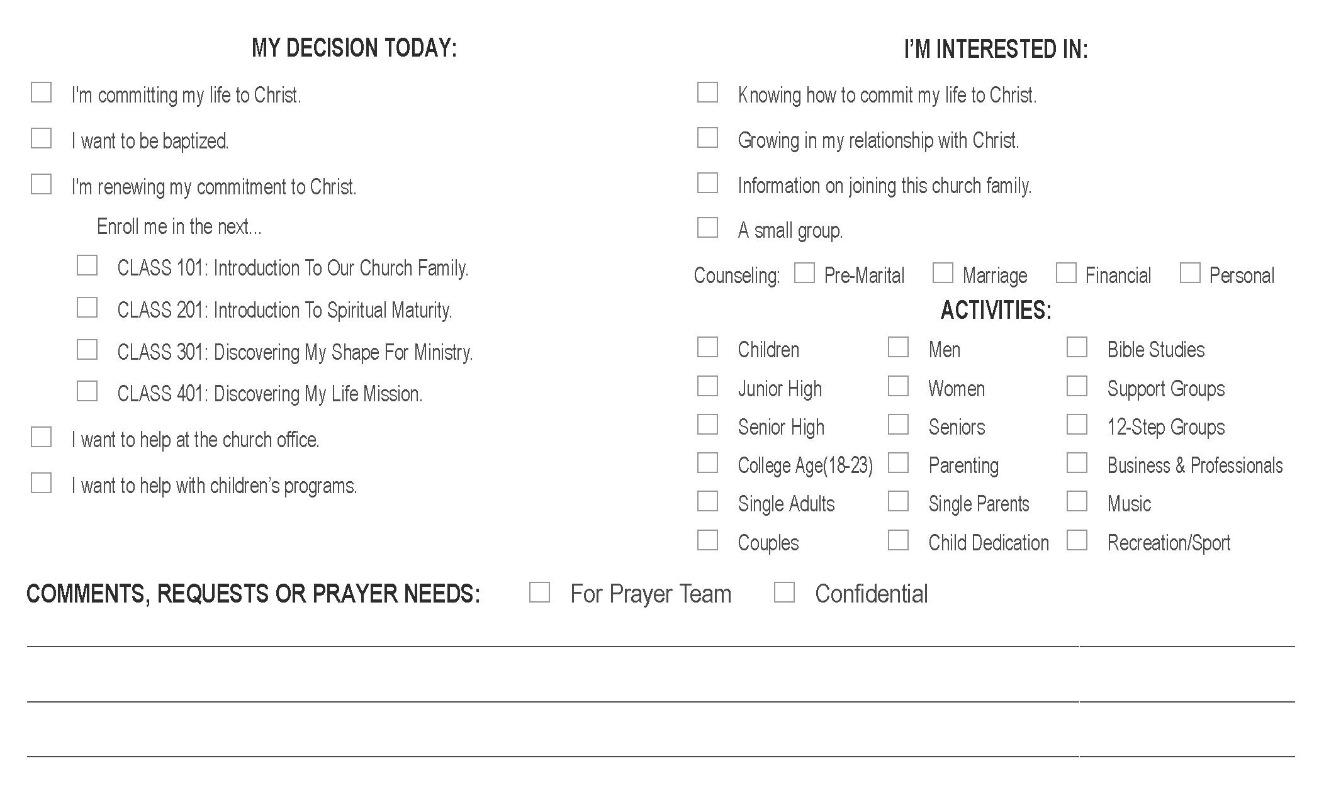

This Business Reply Card is included with a welcome letter to all first time visitors.
FIRST IMPRESSION CARD

Our church wants to serve you better.
Would you give us your opinion please? Thanks!

This is what I noticed first: ________________

________________

________________

This is what I liked best: ________________
________________
________________

This is what I liked least: ________________

––––––––––––––––––––––––––––––––––––––––––––––––––––––––––
Age: 16-29, 30-44, 45-59, 60+ Date Attended: ________________

XII. MATCH YOUR MUSIC TO ________________________________.

Music is the #1 factor in positioning your church

Two common mistakes:

1. We underestimate music’s ______________________

“He put a new song in my mouth... Many people will see this and worship him. Then they will trust the Lord.” Psalm 40:3

2. We try to appeal to ____________________

There is no such thing as “Christian music.”
There are only Christian lyrics.

Suggestions For Planning Music For Services When Unbelievers will be present.

1. Preview all your music!
Is this song doctrinally sound?
Is it understandable to the unchurched?
Does it use terms or metaphors that unbelievers wouldn’t understand?
What is the purpose of this song?

How does it make me feel?

2.. Speed up the tempo!

“Worship the Lord with gladness; come before him with joyful songs.” Psalm 100:2

3. Edit archaic terms from your songs.

4. Find the right balance in the amount of music.

5. Use more performed music than congregational singing in your service for
Unbelievers.

6. Use music for the heart, not the “art.”

7. Encourage your members to write new songs .

“Sing to the Lord a NEW song.” Psalm 96:1

ATTRACTING A CROWD TO WORSHIP

PERSONAL APPLICATION WORK SHEET

1. If you could design a seeker-sensitive service without any restrictions or limitation what elements would you include?

2. Which of these ideas could you implement immediately?

ANSWERS:

What really attracts large numbers of unchurched to a church is:

CHANGED LIVES

II. MAKE IT AS EASY AS POSSIBLE TO ATTEND.

IV. FOCUS ON MAKING GUESTS FEEL COMFORABLE/WELCOMED

First 12 minutes - GUESTS decide if they'll come back.
You never get a second chance to make a first impression.
Your guests first emotion: FEAR

V. BRIGHTEN UP YOUR ENVIROMENT

VI. IF POSSIBLE, PRINT ON PAPER OR DIGITAL A SIMPLE ORDER OF WORSHIP

VIII. READ SCRIPTURE FROM A NEWER TRANSLATION

XII. MATCH YOUR MUSIC TO THOSE YOU WANT TO REACH.

Two common mistakes:

1. We underestimate music’s IMPORTANCE AND POWER

“He put a new song in my mouth... Many people will see this and worship him. Then they will trust the Lord.” Psalm 40:3

2. We try to appeal to EVERYONE

ATTRACTING A CROWD TO WORSHIP

PERSONAL APPLICATION WORK SHEET

1. If you could design a service to be considerate of those without Christ without any restrictions or limitation other than biblical what elements would you include?

2. Which of these ideas could you implement immediate

BUILDING YOUR CONGREGATION
Turning Attenders Into Members

“Now you are no longer strangers to God and foreigners to heaven, but you are members of God’s very own family...and you belong in God’s household with every other Christian.” Ephesians 2:19 (LB)

“In Christ we who are many form one body, and each member belongs to all the others.”
Romans 12:5

I. CREATE A _________________________ WHERE PEOPLE WANT TO JOIN.

The two things people crave most: Love & Acceptance.
(John 13:35) (Romans 15:7)

Fact: Growing churches love and loving churches grow!

Position your church as a family, not as an institution!

II. COMMUNICATE ___________________________ OF MEMBERSHIP.

The Three Parts of the Christian Life:

1. Believing
“BELIEVE on the Lord Jesus and you will be saved.” Acts 16:31 (LB)

2. Belonging

“You are a member of God’s very own family...and you BELONG in God’s household with every other Christian!” Ephesians 2:19 (LB)

3. Becoming

“From the very beginning God decided that those who came to him...should BECOME like his Son...” Romans 8:29 (LB)
Benefits to Membership

1. It identifies me as a genuine believer. Ephesians 2:19; Romans 12:5
- It provides me a spiritual family to support and encourage me.
Galatians 6:1-2; Hebrews 10:24-25
- It gives me a place to discover and use my gifts in ministry.
1 Corinthians 12:4- 27
- It places me under the spiritual protection of godly leaders.
Hebrews 13:17; Acts 20: 28-29
5. It gives me the accountability I need to grow. Ephesians 5:21

Help people see “Membership” as a step of spiritual growth rather than as an organizational ritual.

III. DEVELOP ____________________________ TO ASSIMILATE NEW MEMBERS.

“Make plans by seeking advice.” Proverbs 20:18

Questions You Need To Ask:
1. What does God expect from members of His church?
2. What do we expect from our members right now?
3. What kinds of people already make up our
congregation?
4. How will that change in the next 5 to 10 years?
5. What do our members value?
6. What are new members’ greatest needs?
7. What are our long-term members’ greatest needs?
8. How can we make membership more meaningful?
9. How can we insure that members feel loved and cared
for?
10. What do we owe our members?
11. What resources or services could we offer our
members?
12. How could we add value to what we already offer?

Five Questions Prospective Members Ask:

1. Do I fit here? (acceptance)
2. Does anybody want to know me? (friendship)
3. Am I needed? (value)
4. What is the advantage of joining? (benefit)
5. What is required of members? (expectations)

IV. ESTABLISH A REQUIRED _____________________________.

The manner in which people join your church will determine their effectiveness as members for years to come.

A strong membership class will grow a strong church.

Outline of Purpose 1
Discovering The Everywhere Church Family

WELCOME 3
SESSION ONE: OUR PURPOSE 4
The Reason for Everything 5
God’s Five Purposes for Your Life on Earth 7
Why You Need the Church 11
What Does It Mean to Be a Christian? 12
Baptism: How You Identify with God’s Family 18
The Lord’s Supper: Communion with God’s Family 23

SESSION TWO: OUR STRATEGY 25
Our Motto 26
Our Purpose Statement 27
Circles of Commitment 28
Development Diamond 29
Our Everywhere Church Values 30
Our Faith Statement 34
The Essentials We Believe 35

SESSION THREE: OUR STORY 37
Our History 40

SESSION FOUR: OUR EVERYWHERE CHURCH FAMILY 47
What Is the Church? 48
Why Become a Member? 51
Our Model for Membership: The First Church 53
What Are My Next Steps? 57

- The difference between “attenders” and “members” can be summed up in one word:______________________________

- People will leave your church no matter what. When your church adopts a membership covenant, you are choosing who stays!

The Everywhere Church
Membership Covenant

What Does It Mean to Be a Member of EVERYWHERE CHURCH?

The Bible is very clear about the privileges and responsibilities of belonging to a church family. These are spelled out in our Membership Covenant, which has been signed by millions of people who are part of purpose driven churches, along with people who are now members of our Everywhere Church family.

Having received Jesus Christ as my Lord and Savior and been baptized by full immersion, and being in agreement with Everywhere Churches statements, strategy, and structure, I now feel led by the Holy Spirit to unite with the Everywhere Church family. In doing so, I commit myself to God and to the other members to do the following:

- I will protect the unity of my church.
- By acting in love towards other members
- By refusing to gossip and by resolving conflicts using Matthew 18:15–17
- By following the leaders
“If another believer sins against you, go privately and point out the offense. If the other person listens and confesses it, you have won that person back. But if you are unsuccessful, take one or two others with you and go back again, so that everything you say may be confirmed by two or three witnesses. If the person still refuses to listen, take your case to the church. Then if he or she won’t accept the church’s decision, treat that person as a pagan or a corrupt tax collector.”
MATTHEW 18:15–17 (NLT)
So let us concentrate on the things which make for harmony, and on the growth of one another’s character.
ROMANS 14:19 (PHILLIPS)
Live in complete harmony with each other—each with the attitude of Christ toward the other.
ROMANS 15:5 (TLB)
Now that by your obedience to the truth you have purified yourselves and have come to have a sincere love for other believers, love one another earnestly with all your heart.
1 PETER 1:22 (GNT)
Do not let any unwholesome talk come out of your mouths, but only what is helpful for building others up according to their needs, that it may benefit those who listen.
EPHESIANS 4:29 (NIV)
Obey your leaders and submit to them, for they keep watch over your souls and will give an account for their work. Let them do this with joy and not with complaints, for this would be no advantage for you.
HEBREWS 13:17 (NET)
- I will share the responsibility of my church.
- By praying for its growth
- By inviting the unchurched to attend
- By warmly welcoming those who visit
We always thank God for all of you and pray for you constantly.
1 THESSALONIANS 1:2 (NLT)

“ ‘Go out into the country lanes . . . and urge anyone you find to come, so that the house will be full.’ ”
LUKE 14:23 (TLB)
So warmly welcome each other into the church, just as Christ has warmly welcomed you; then God will be glorified.
ROMANS 15:7 (TLB)
- I will serve the ministry of my church.
- By discovering my gifts and talents
- By being equipped by my pastors to serve
- By developing a servant’s heart
Serve one another with the particular gifts God has given each of you.
1 PETER 4:10 (PHILLIPS)
It was [God] who “gave gifts to people”; he appointed . . . others to be pastors and teachers. He did this to prepare all God’s people for the work of Christian service, in order to build up the body of Christ.
EPHESIANS 4:11–12 (GNT)
When you do things, do not let selfishness or pride be your guide. Instead, be humble and give more honor to others than to yourselves. Do not be interested only in your own life, but be interested in the lives of others. But [Christ] gave up his place with God and made himself nothing. He was born as a man and became like a servant.
PHILIPPIANS 2:3–4, 7 (NCV)
- I will support the testimony of my church.
- By attending faithfully
- By living a growing and godly life
- By giving regularly
Let us not give up the habit of meeting together . . . let us encourage one another.
HEBREWS 10:25 (GNT)
But whatever happens, make sure that your everyday life is worthy of the Gospel
of Christ.
PHILIPPIANS 1:27 (PHILLIPS)
On every Lord’s Day each of you should put aside something from what you have earned during the week.
1 CORINTHIANS 16:2 (TLB)
One-tenth of all crops belongs to the Lord, including the crops from fields and the fruit from trees. That one-tenth is holy to the Lord.
LEVITICUS 27:30 (NCV)

VI. CREATE OPPORTUNITIES TO BUILD _____________________________.

- Retreats
- Fellowship
- Name Tags
- Relational activities as a part of every meeting

VII. ENCOURAGE EVERY MEMBER TO JOIN A _________________________.

VIII. KEEP COMMUNICATION CHANNELS OPEN.

“Be sure you know the condition of your flock; give attention to your herds.” Proverbs 27:23

The channels we use for feedback:

1. The Welcome/Registration Card
2. CARE Callers Reports
3. Small Group Leader Reports
4. Prayer Chain
5. E-Mail Responses

Channels we use to communicate a message to the congregation:

• Social Media • Email
• Video • Voice mail
• Newsletters • Podcasts
• Prayer chains • CARE callers
• Postcards • Internet (Web site)
*Texts *Whats App

People tend to be down on what they aren’t up on!

IX. MAKE YOUR MEMBERS FEEL SPECIAL!

Suggestions:

- Print a nice certificate of baptism and membership

2. New member banquets/receptions

3. Use public testimonies

4. Take their prayer requests seriously

5. Give them a meaningful ministry role

6. Challenge them with an eternal vision

7. Pastor’s Coffee

8. Staff Receptions

- Send cards on special days

ANSWERS

I. CREATE A CLIMATE WHERE PEOPLE WANT TO JOIN.

II. COMMUNICATE THE VALUE OF MEMBERSHIP.

III. DEVELOP A PLAN TO ASSIMILATE NEW MEMBERS.

IV. ESTABLISH A REQUIRED A REQUIRED MEMBERSHIP SEMINAR.

V. DEVELOP A MEMBERSHIP covenant

- The difference between “attenders” and “members” can be summed up in one word: COMMITMENT

VI. CREATE OPPORTUNITIES TO BUILD RELATIONSHIPS.

VII. ENCOURAGE EVERY MEMBER TO JOIN A E-GROUP/HOST HOME.

APPLICATION QUESTIONS:

HOW IMPORTANT IS IT FOR UNBELIEVERS TO UNDERSTAND THE GOSPEL BEFORE JOINING YOUR CHURCH?

WHY DO YOU THINK IT’S IMPORTANT THAT NEW MEMBERS AGREE TO ESSENTIALS OF THE CHRISTIAN FAITH AND NON-ESSENTIALS?
DEVELOPING MATURE MEMBERS
Moving People From The Congregation Into The Committed

“...building up the church, the body of Christ, to a position of strength and maturity.”
Ephesians 4:12 (LB)

“Our greatest wish and prayer is that you will become mature Christians.”
2 Corinthians 13:9 (LB)

EVERYWHERE CHURCHES’S STRATEGY IS BASED ON
6 BELIEFS ABOUT SPIRITUAL GROWTH:

I. GROWTH BEGINS WITH ____________________

UNDERSTANDING THE NATURE OF COMMITMENT

1. We become what ____________________

A great commitment to the Great Commandment & Great Commission
will produce a Great Christian!

2. Every church is ____________________ by what it is committed to.

“... your faith in God has become known everywhere.” 1 Thessalonians 1:8

3. You must ____________________ or you won’t get it!

How to elicit commitment:

- ________________________________
- ________________________________

4. The greater the commitment you ask for, __________________________

“Any of you who does not give up everything he has cannot be my disciple.”
Luke 14:33

5. If your church doesn’t ask for commitment _________________________

6. People want to be committed to something that ____________________

7. Build _________ commitment, rather than ____________________ it.

II. GROWTH IS A ________________________________

"Learn to be mature." Prov. 8:5 (GN)
"Continue to grow in the grace and knowledge of our savior Jesus Christ." 2 Peter 3:18 (GN)

There are no shortcuts!

1. IT IS NOT AUTOMATIC

"You have been Christians for a long time now, and you ought to be teaching others, but instead ... you need someone to teach you ... When a person is still living on milk, it shows he isn't very far along in the Christian life ... He's still a baby Christian!" Heb. 5:12-13 (LB)

2. IT TAKES DISCIPLINE

"Take the time and the trouble to keep yourself spiritually fit."
1 Tim. 4:7b (Ph)
"Discipline yourself for the purpose of godliness." (NASB)

This means as a leader you must:

- Decide on ____________________

Ask yourself: What does a person have to know to grow?

- Design a ____________________

Ask yourself: How can we help people to take the next growth step?

- Develop your ____________________

Provide as many options as possible for people to grow.
Deliver the truth in a variety of ways.
People learn in different ways... at different times...
for different reasons... at different speeds...

III. GROWTH INVOLVES ____________________

The term “spiritual habits” is less threatening to new believers than
“spiritual disciplines.”

Dostoyevski: “The second half of a man’s life is determined by the habits he acquired during the first half.”

THE 3 MOST IMPORTANT SPIRITUAL HABITS
(Putting Christ first in my Time, Money, and Relationships)

A DAILY ____________________
Mark 1:35

A WEEKLY____________________
1 Corinthians 16:2

A COMMITTED ____________________
Hebrews 10:25

IV. GROWTH IS MEASURED BY ___________________________
(Not just knowledge)

BUILDING A BALANCED CHRISTIAN EDUCATION PROGRAM BASED ON THE FIVE LEVELS OF LEARNING
The Building Blocks of Spiritual Growth

KNOWLEDGE: Knowing the content of God’s Word
Gaining a working knowledge of the books, events, and people of the Bible.

“My people are destroyed from lack of knowledge.” Hosea 4:6

PERSPECTIVE: Seeing things from God’s point of view
Understanding why God does what He does.

“Solid food is for the mature, who because of practice have their senses
trained to discern good and evil.” Hebrews 5:14 (NAS)

“The man without the Spirit does not accept the things that come from
the Spirit of God... because they are spiritually discerned.” 1 Corinthians 2:14

CONVICTIONS: Developing godly values, commitments and motivations.

“Faith is the assurance of things hoped for, the conviction of things not seen.”
Heb. 11:1 (NAS)

“The faith which you have, have as your own conviction before God.”
Rom. 14:22 (NAS)

EVERY GROUP, SEMINAR OR MESSAGE MUST BUILD CONVICTION

SKILLS: Learning the “how-to’s” of Christian living and ministry.

“If the ax is dull and its edge unsharpened, more strength is needed but
skill will bring success.” Eccl. 10:10

“Do your best to present yourself to God as one approved, a workman...
who correctly handles the word of truth.” 2 Tim. 2:15

CHARACTER: Becoming like Christ in attitudes and actions

“The GOAL of our instruction is love from a pure heart and a good conscience and a sincere faith.” 1 Tim. 1:5 (NAS)

“We must become like a mature person, growing until we become like Christ and have his perfection.” Eph. 4:13b (NCV)

“You are living a brand new kind of life that is continually learning more and ore of what is right, and trying constantly to be more and more like Christ...” Colossians 3:10 (LB)

THE FIVE LEVELS BUILD ON EACH OTHER

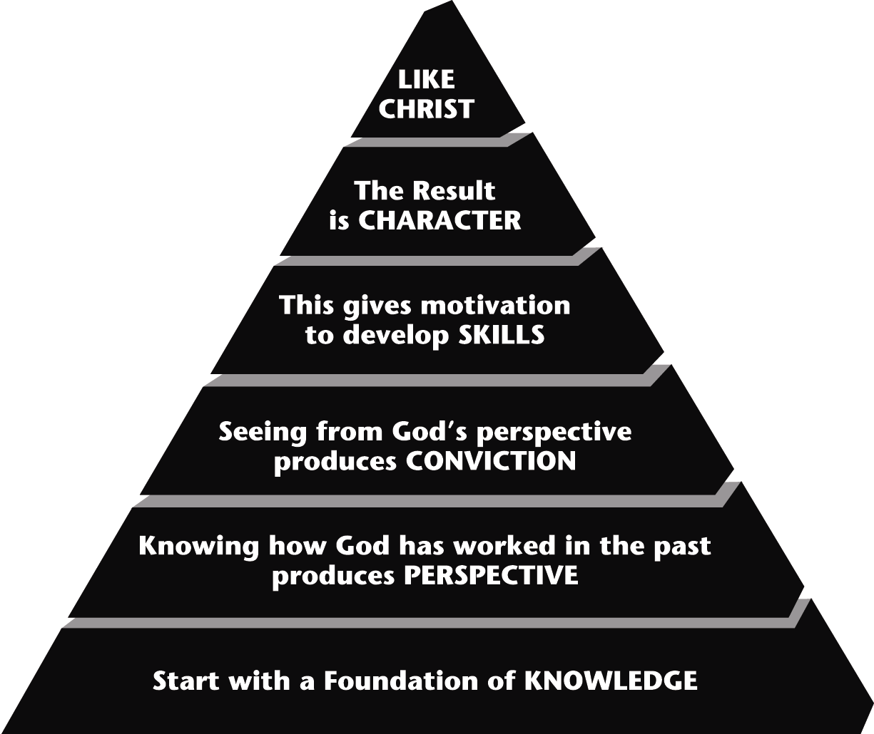

VITAL QUESTIONS TO ASK GOAL

1. What do our members have to KNOW in order to grow? Know the Word of God

2. What PERSPECTIVES do we want them to have? Have the mind of God
(About God, the Bible, themselves, Satan, the world, etc.)

3. What CONVICTIONS do we want them to hold? Have the heart of God

4. What SKILLS do they need for life and ministry? Do all to the glory of God

5. What CHARACTER qualities do we want them to exhibit? Have the character of God

V. GROWTH IS STIMULATED BY ____________________

“And let us consider how we may spur one another on toward love and
good deeds.” Heb. 10:24 (NIV)

VI. GROWTH REQUIRES PARTICIPATION IN ____________________

Without evangelism we become self centered
Without discipleship we become experience centered
Without ministry we become knowledge centered
Without fellowship we become results centered
Without worship we become man centered

THROUGH ALL 5 PURPOSES WE BECOME CHRIST CENTERED

THE LEADERSHIP FACTOR:

“My dear children, for whom I am again in the pains of childbirth until Christ is formed in you...” Gal. 4:19 (NIV)

ANSWERS:

I. GROWTH BEGINS WITH commitment

1. We become what WE ARE COMMITTED TO

2. Every church is KNOWN by what it is committed to.

3. You must ASK FOR commitment or you won’t get it!

- BE SPECIFIC
- SHOW THE BENEFITS

4. The greater the commitment you ask for, THE GREATER THE RESPONSE

5. If your church doesn’t ask for commitment OTHERS WILL

6. People want to be committed to something that GIVES THEIR LIVES MEANING

7. Build ON commitment, rather than TOWARDS it.

II. GROWTH IS A PROCESS

- Decide on PRIORITIES

- Design a PLAN

- Develop your PROGRAMS

III. GROWTH INVOLVES DEVOLOPING SPIRITUAL HABITS

A DAILY TIME WITH GOD

A WEEKLY TITHE/OFFERING TO GOD

A COMMITTED TEAM FOR GOD (E-GROUP/HOST HOME)

IV. GROWTH IS MEASURED BY FIVE FACTORS

V. GROWTH IS STIMULATED BY RELATIONSHIPS

VI. GROWTH REQUIRES PARTICIPATION IN ALL FIVE PURPOSES

APPLICATION QUESTIONS:

What did Jesus command us to do if we wanted to build a strong life that could not be shaken ?

How important is knowing the word related to the above question?

E-GROUPS/HOST HOMES

“Let us consider how we may spur one another on toward love and good deeds. Let us not give up meeting together ... but let us encourage one another...” Heb. 10:24-25

- Every ____________________ needs to be part of a Host Home!

- Every Volunteer ministry should be ____________________ around a Host Home.

I. THE NEW TESTAMENT MODEL

THE AMAZING GROWTH OF THE FIRST CHURCH
See Acts 1:15, 2:41,47, 4:4, 5:14,28, 6:1,7, 21:20

During its first 25 the Jerusalem church grew from 120 people
to over _________________

WHERE DID THEY PUT ALL THOSE PEOPLE?

“(They met) day after day, in the Temple courts and from house to house...”
Acts 5:42

2 Types of Meetings

- Large group: ____________________

- Small group: ____________________

“Greet the church that meets in their home.” Rom. 16:5
Also Acts 2:46, 8:3, 16:40, 20:20; 1 Cor. 16:19; Col. 4:15

In the first church, the small groups were the base for all ministry and fellowship.

SMALL GROUPS AND MINISTRY GO TOGETHER!

A NEW TESTAMENT EXAMPLE: ACTS 6:1-7

“In those days...the number of disciples was increasing...”

1. Church growth causes ____________________ (vs.1b)

“...there were rumblings of discontent...” (LB)

2. Problems are always ____________________ (vs.1c)

“The Greek-speaking Jews claimed that their widows were being neglected in the daily distribution of food.” (GN)

INSIGHT: When people complain, they are often revealing: ____________________________________

3. The pastors cannot _______________________ (vs.2)

“It would not be right for us to neglect the ministry of the word of God in order to wait on tables.”

4. ____________________ are to assist the pastors (vs.3)

“Choose seven men...full of the Spirit and wisdom. We will turn this
responsibility over to them...”

5. The pastors are to focus on ____________________ (vs.4)

“We will give our attention to prayer and the teaching of the Word.”

6. The result of volunteer ministry was ____________________ (vs.5,7)

“This proposal pleased the whole group...So the word of God spread and the number of disciples in Jerusalem increased rapidly.”

II. THE OLD TESTAMENT MODEL: EXODUS 18:13-26

THE PROBLEM: Moses was doing all the work by himself. (vs.17-18)

THE SOLUTION: They divided up the ministry among God’s people. (vs.21-22)

THE STRATEGY: Moses appointed

• Leaders of 1000 • Leaders of 50

• Leaders of 100 • Leaders of 10

THE RESULT: Moses was relieved and everyone had his needs satisfied (vs.23)

III. A CONTEMPORARY EXAMPLE: SEOUL, KOREA

Yoido Full Gospel Church - 750,000 members

IV. WHAT DID THE FIRST HOME GROUPS DO?

ACTS 2:42-47: THEY WERE CENTERED AROUND CHRIST!

1. __________________________

“They devoted themselves to the apostles teaching...” (Maturity)

2. ________________________ (Membership)

“...they joined in the fellowship... and ate together with glad and sincere hearts...”

3. _________________________ (Magnification)

“...they devoted themselves to the breaking of bread and prayer...”

“...they were praising God...”

4. ________________________ (Ministry)

“...they gave to anyone as he had a need...”

5. _________________________ (Mission)

“And the Lord added to their number daily those who were being saved.”

A healthy group will: _________________________

The secret: Appoint a _________________________ for each purpose! (base)

Nothing happens until someone “owns” each of the purposes.

Put the Diamond in the center of every Host Home!

Every group does ALL 5 purposes!

ADVANTAGES OF MEETING IN HOMES

1. You can have longer to accomplish your purpose

It’s difficult to fulfill all 5 purposes in an hour.

2. It has a more A MORE INTIMATE, RELAXED ATMOSPHERE
3. They are infinitely EXPANDABLE
4. They are geographically UNLIMITED
5. They are good STEWARDSHIP

V. GROUPING PEOPLE BY AFFINITY: THE KEY TO INVOLVEMENT

Types of AFFINITY

COMMON ____________________ COMMON _________________

COMMON ____________________ COMMON ____________________

COMMON ____________________ COMMON ____________________

VI. THE BENEFITS OF BEING IN A HOST HOME.

1. I’ll feel like a real part of____________________.

2. I’ll understand ____________________ better.

3. I will receive the ____________________ I need to grow.

4. I’ll be able to____________________ better with support.

5. It is a safe place to ____________________ .

6. It is a natural relaxed way to ____________________.

VIII. THE KEY TO A SUCCESFUL HOST HOME MINISTRY:

____________________________________________

“When Jesus saw the crowds, he had compassion on them - because their problems were so great and they didn’t know what to do or where to go for help. They were like sheep without a shepherd. Jesus said to his followers, “There are so many people to harvest but only a few workers to help harvest them. Pray to `the Lord, who owns the harvest, that he will send more workers to gather his harvest.” Matthew 9:36-38 (NIV/LB)

6 FOUNDATIONAL CONVICTIONS

1. Every member deserves ____________________. (All ages.)

2. The best place to provide it is through ____________________.

HOST HOMES are not a program but a strategy.

Every ministry need to be structured around HOST HOMES.

3. Every group deserves a____________________.

Jesus: “If you love me... take care of my sheep.” John 21:17

A Shepherd for every Sheep!

4. Every group needs to ____________________.

Membership: help people to Christ & to the fellowship of our church family.
Maturity: help people grow in Christlikeness.
Ministry: help people find the place of service that best uses their SHAPE.
Mission: help people reach their unsaved friends & coworkers for Christ.
Magnify: help people glorify God through worship.

5. Every purpose needs ____________________ in every HOST HOME.

5 people to insure that each of the 5 purposes is given adequate attention

6. The best way to raise up quality leaders is through ____________________.

“David shepherded them with integrity of heart; with skillful hands he led them.”
Psalm 78:72 (NIV)

ANSWERS:

- Every MEMBER needs to be part of a Host Home!

- Every Volunteer ministry should be BUILT around a Host Home.

During its first 25 the Jerusalem church grew from 120 people
to over 100,000

- Large group: CELEBRATION

- Small group: CONGREGATIONS

1. Church growth causes CONFLICT (vs.1b)

2. Problems are always UNMET NEEDS (vs.1c)

INSIGHT: When people complain, they are often revealing: THEIR MINISTRY PASSION

3. The pastors cannot MEET ALL THE NEEDS (vs.2)

4. MEMBERS/LAY MINISTERS are to assist the pastors (vs.3)

- The pastors are to focus on PREACHING AND PRAYER (vs.4)

6. The result of volunteer ministry was MULTIPLIED GROWTH (vs.5,7)

1. THEY GREW SPIRITUALLY (MATURITY)

2. THEY FELLOWSHIPED (Membership)

3. THEY WORSHIPPED (Magnification)

4. THEY MINISTERED TO EACH OTHER (Ministry)

5. THEY EVANGELIZED THE LOST (Mission)

A healthy group will: REPRODUCE IT’SELF

The secret: Appoint a CHAMPION for each purpose! (base)

Types of AFFINITY

COMMON CULTURE COMMON CITY

COMMON CONCERN COMMON CALENDAR

COMMON CRISIS COMMON COMMITMENT

VI. THE BENEFITS OF BEING IN A HOST HOME.

1. I’ll feel like a real part of CHURCH FAMILY.

2. I’ll understand GODS WORD better.

3. I will receive the ACCOUNTABLITY I need to grow.

4. I’ll be able to HANDLE STRESS better with support.

5. It is a safe place to DEVELOP MY GIFTS AND TALENTS .

6. It is a natural relaxed way to SHARE MY FAITH WITH UNBELIEVERS.

VIII. THE KEY TO A SUCCESFUL HOST HOME MINISTRY:

A LEADER WITH A SHEPHERDS HEART

6 FOUNDATIONAL CONVICTIONS

1. Every member deserves PERSONAL CARE. (All ages.)

2. The best place to provide it is through E-GROUPS/HOST HOMES.

3. Every group deserves a HOST OR SHEPHERD WHO LOVES THEM.

4. Every group needs to FULFILL THE PURPOSES OF JESUS.

5. Every purpose needs A CHAMPION in every HOST HOME.

- The best way to raise up quality leaders is through APPRENTICES .

APPLICATION QUESTION:

WHAT WOULD YOUR HOST HOME LOOK LIKE IF IT BECAME LIKE THE FIRST HOST HOMES IN THE NEW TESTAMENT BOOK OF ACTS?

EMPOWERING YOUR CORE FOR MINISTRY
How To Turn An Audience Into An Army

GALLUP SURVEY: Only _____% of all laymen are active in a ministry.

An additional 50% have no interest at all.

BUT

______ % said they’d like to be involved but have never been
asked or don’t know how.

I. TEACH THE __________________________ FOR VOLUNTEER MINISTRY.

4 Pillars of Volunteer ministry: Romans 12:1-8

1. Every believer is ______________________________

2. Every ministry is ________________________

3. We are dependent __________________________

4. Ministry is the expression of my S.H.A.P.E.

S. ____________________________ (1 Cor. 12; Rom. 8; Eph. 4)

H. ____________________________ (Matt. 12:34; Prov. 4:23; Ps. 37.4)

A. ____________________________ (Ex. 31:3; 1 Cor. 12:5)

P. ____________________________ (1 Cor. 2:11 LB)

E. ____________________________ (Rom. 8:28; 2 Cor. 1)

II. ESTABLISH A MINISTRY PLACEMENT ____________________.

A PATHWAY FOR EXISTING CHURCHES AND GOAL FOR NEW ONES.

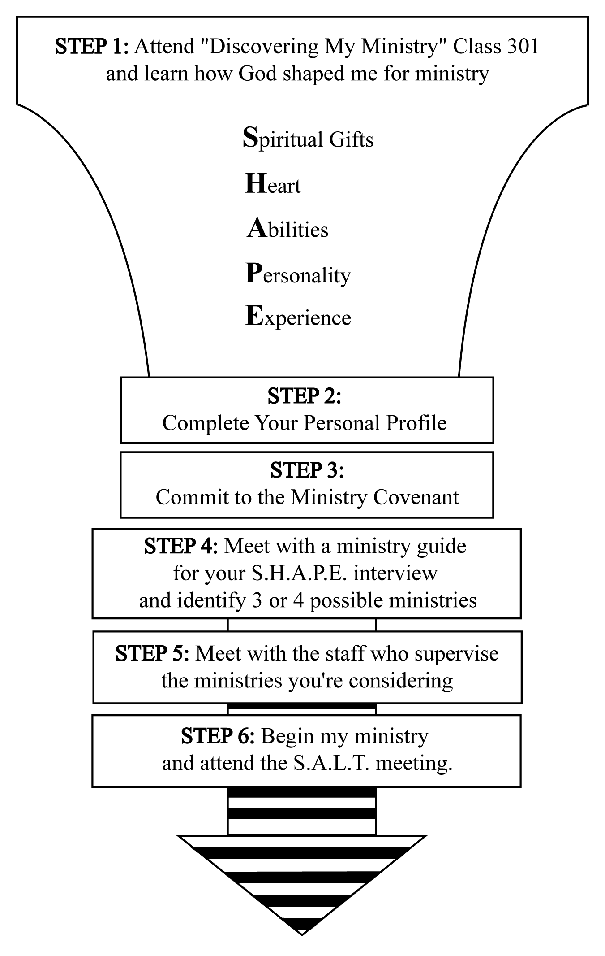

III. STREAMLINE YOUR ORGANIZATIONAL STRUCTURE TO
MAXIMIZE MINISTRY AND MINIMIZE ____________________.

The most valuable thing people give you is their time.

IV. PROVIDE ______________________________ TRAINING.

Warning: Don’t wear people out with pre-service training!

V. NEVER START A MINISTRY WITHOUT A ________________________.

The most critical factor in a new ministry start-up is not the idea but the _____________________.

Everything rises or falls on leadership!

Trust God’s timing! Never force a ministry!

VI. ESTABLISH MINIMUM ______________________________________.

But don’t bury them with procedures or committees.

VII. ALLOW PEOPLE TO __________________________________ MINISTRIES
GRACEFULLY, WITHOUT GUILT!

Give them freedom to do 3 things:
1. Examine

2. Experiment

3. Exercise

IX. PROVIDE THE_______________________ needed.

1. Material Support
Access to TOOLS.

2. Communications Support
Develop multiple communication channels to stay in touch with your
core of lay leaders and ministers
• TEXT
• Internet Web Page:
• EMAIL
• SOCIAL MEDIA

3. Promotional Support: Keep your ministries visible!
• Set up ministry tables when you’ve grown to a larger space
• Give every minister a nametag
• Hold a ministry fair at least twice a year
• Provide space to show your ministry
• Refer to ministries publicly in your gatherings

• Plan special events to honor your lay ministers

- Moral Support

X. DELEGATE ____________________________ WITH RESPONSIBILITY.

Trust your people!

The key to motivation: ___________________________

How to Bring Out the Best in Others:

- Give them a challenge

- Give them control

- Give them the credit

People will be as creative as the structures allow them to be!

XI. ALWAYS KEEP _____________________________ BEFORE THEM.

The Nehemiah Principle: Vision must be renewed every ________________.

ANSWERS:

EMPOWERING YOUR CORE FOR MINISTRY
How To Turn An Audience Into An Army

GALLUP SURVEY: Only 10 % of all laymen are active in a ministry.

An additional 50% have no interest at all.

BUT

40 % said they’d like to be involved but have never been
asked or don’t know how.

I. TEACH THE biblical basis FOR VOLUNTEER MINISTRY.

4 Pillars of Volunteer ministry: Romans 12:1-8

1. Every believer is minister

2. Every ministry is important

3. We are dependent on each other

S. spiritual gifts (1 Cor. 12; Rom. 8; Eph. 4)

H. heart (Matt. 12:34; Prov. 4:23; Ps. 37.4)

A. abilities (Ex. 31:3; 1 Cor. 12:5)

P. personality (1 Cor. 2:11 LB)

E. experiences (Rom. 8:28; 2 Cor. 1)

II. ESTABLISH A MINISTRY PLACEMENT process.

III. STREAMLINE YOUR ORGANIZATIONAL STRUCTURE TO
MAXIMIZE MINISTRY AND MINIMIZE maintiance/meetings.

IV. PROVIDE on the job TRAINING.

V. NEVER START A MINISTRY WITHOUT A leader.

The most critical factor in a new ministry start-up is not the idea but the leadership.

VI. ESTABLISH MINIMUM standards and guidelines.

VII. ALLOW PEOPLE TO quit or change MINISTRIES
GRACEFULLY, WITHOUT GUILT!

IX. PROVIDE THE support needed.

X. DELEGATE authority WITH RESPONSIBILITY.

The key to motivation: OWNERSHIP

XI. ALWAYS KEEP THE VISION BEFORE THEM.

The Nehemiah Principle: Vision must be renewed every 26 DAYS.

Application Questions:

Why is this a huge tool for the church to grow and the pastors not to burn out? Ephesians 4
LEADING YOUR CHURCH THROUGH CHANGE
UNDERSTAND THE COMPONENTS OF CHANGE

1. YOU MUST DEVELOP AN ______________________________________
ABOUT GROWTH.

Why We Must Never Stop Growing:

- Because God’s Word __________________________

Matt. 28:18-20; Mark 16:15; Luke 24:46-48; John 20:21; Acts 1:8

- Because the needs of people _________________________

“...The Lord is patient, not wanting anyone to perish, but everyone to come to repentance.” 2 Peter 3:9

“For Christ’s love compels us.” 2 Cor. 5:14

- Because church growth is _______________________

“Under Christ’s control, the whole body is nourished and held together by its joints and ligaments, and grows as God wants it to grow.” Col. 2:19 (GN)

Current Criticisms of Church Growth:

- “God isn’t interested in numbers.”

- “The church should focus on quality, not quantity.”

- “Large churches are shallow and lack commitment.”

FACT: There is no correlation between the ____________________ and
____________________ of a church.

2. DECIDE IF YOUR CHURCH _________________________ .

Aspects to consider:

- ____________________

Is this church in the right place for growth?
Is this church worth changing?
Does it need to die and be reborn somewhere else?
Is there a more receptive area? (Matt. 10:14)
Could I be more effective somewhere else?
What is the realistic potential even if the church is renewed?

- ____________________

Am I the right person to lead this change?

Is this the kind of church I should be pastoring?
Do I match the congregation? Do I match the community?
Is the existing leadership likely to support me in change?
(If they stay, can the church grow?)

- ________________________

Am I willing to give the rest of my life to this church?

3. MAKE A PUBLIC COMMITMENT TO _________________ .

Law of Leadership: Change takes ____________________

The longer a church has been plateaued, the longer it will take to
______________________________________

The only times you can move quickly:

- _____________________________________

- _____________________________________

- _________________________________________________

4. BEGIN SHARING____________________.

- Have a biblical basis for everything

- Condense your strategy into an acrostic

- Create discontent with the status quo by showing the benefits of growth

- Appeal to the best in people

- Build morale - We CAN do this for God’s glory

- Create a sense of destiny

5. EXPOSE YOUR KEY LEADERS TO____________________ .

This is the fastest way to create change

“You became imitators of us...and so you became a model to all believers in Macedonia and Achaia.” 1 Thess. 1:6-7

Realize “Education is Alienation”

BIG MISTAKE: To go home and try to institute new ideas by simply telling them.

Use podcasts...books...visit churches

6. BUILD ON YOUR ____________________, NOT YOUR ____________________ .

THE SECRET is to do better ____________________

Don’t begin with your problems, begin with ____________________

7. BE ____________________ IN INTRODUCING CHANGE.

- Choose your battles strategically

- Focus on the most important and easiest things to change

- Compromise on non-essentials

- Be a proponent of the new, not an opponent of the old!

- Respect & enlist support from the “legitimizers” in your church

- Call every change “an experiment”

- Know how many “CREDITS” a change will cost and how many “CREDITS” you have to spend!

CREDIT: The amount of trust people place in your leadership

3 Things Build Trust:

_______________________________

______________________________

______________________________

8. DON’T TAKE CRITICISM _________________________.

There are 3 common criticisms:

1. THE CARE ISSUE:

2. THE CONTROL ISSUE:

Growth upsets the balance of power between old-timers & new-comers.

3. THE COMFORT ISSUE:

We must be willing to minister outside our comfort zones.

The real issue: SELFISHNESS

8. YOU MUST BE WILLING TO LET PEOPLE LEAVE THE CHURCH

10. ____________________ AND ____________________ PEOPLE FOR THE
CHANGES THEY DO AGREE TO MAKE.

Be grateful for minor changes!

Focus on ____________________, not ____________________!

“An intelligent person aims at wise action, but a fool starts off in many directions.” Prov. 17:24 (GN)

ANSWERS:

LEADING YOUR CHURCH THROUGH CHANGE
UNDERSTAND THE COMPONENTS OF CHANGE

1. YOU MUST DEVELOP AN UNSHAKEABLE CONVICTION
ABOUT GROWTH.

Why We Must Never Stop Growing:

- Because God’s Word COMMANDS IT

- Because the needs of people DEMAND IT.

- Because church growth is GODS WILL.

FACT: There is no correlation between the SIZE and
STRENGTH of a church.

2. DECIDE IF YOUR CHURCH SHOULD BE CHANGED .

Aspects to consider:

- LOCATION

- LEADERSHIP

- LONGEVITY

3. MAKE A PUBLIC COMMITMENT TO STAY .

Law of Leadership: Change takes TIME

The longer a church has been plateaued, the longer it will take to
GET GROWING AGAIN.

The only times you can move quickly:

- IN THE HONEYMOON

- IN A CRISIS

- AFTER YOU’VE CREATED A CULTURE OF CHANGE.

4. BEGIN SHARING VISION.

5. EXPOSE YOUR KEY LEADERS TO MODEL CHURCHES .

6. BUILD ON YOUR STRENGTHS, NOT YOUR WEAKNESSES .

THE SECRET is to do better WHAT YOU DO BEST

Don’t begin with your problems, begin with YOUR DREAMS

7. BE STRATEGIC IN INTRODUCING CHANGE.

3 Things Build Trust:

COMPASSION

COMPETENCE

CONSISTENCY

8. DON’T TAKE CRITICISM PERSONALLY.

10. AFFIRM AND APPRECIATE PEOPLE FOR THE
CHANGES THEY DO AGREE TO MAKE.

Focus on PROGRESS, not PERFECTION!

APPLICATION:

What’s the first change you feel you need to make at your church or host home?

AUTHENTIC LEADERSHIP
The Type of Leader God Uses

“Remember your leaders, who spoke the word of God to you. Consider the outcome of their way of life and imitate their faith.” Hebrews 13:7

The common denominator of all growing churches:

Leadership that is ____________________

Four Ways The “Faith Factor’ Is Seen In Leadership

I. GOD USES THE PERSON WHO ____________________

Nothing happens until someone: STARTS DREAMING

A church never outgrows: ITS VISION

You cannot delegate: FAITH IN GOD

GOALS ARE: STATEMENTS OF FAITH

Proverbs 11:27 (GN); Isaiah 54:2-3

Ask: What would I attempt for God if I knew I couldn’t fail?

“God... is able to do far more than we would ever dare to ask or even dream of -infinitely beyond our highest prayers, desires, thoughts, or hopes!”
Ephesians 3:20 (LB)

Two common mistakes we make in goal setting:

• We set them: ____________________

• We try to reach them: ____________________
Overestimate - 1 year Underestimate - 10 years

What to consider when setting growth goals:

1. How long do l intend to stay

2. How many people live in our area

3. What are my spiritual gifts

Three Parts To Getting God’s Vision

- First, God shows you ____________________

- Next, God shows you ____________________

- Then, God shows you ____________________

Stop praying: Lord bless what i’m doing

Instead pray: Help me to do what you’re blessing

II. GOD USES THE PERSON WHO _________________________________

“They risked their lives for the name of our Lord Jesus Christ.”
Acts 15:26 (NIV)

Matthew 25 - “Unfaithful” means UNWILLING TO RISK

Three Approaches to Ministry

RISKTAKER
CARETAKER
UNDERTAKER

Satan’s greatest tool against pastors: FEAR OF FAILURE
Proverbs 29:25

Two Ways to Eliminate It

1. REDEFINE FAILURE

2. DON’T COMPARE YOURSELF TO OTHERS

“Each man should test his own actions. Then he can take pride in himself without comparing himself to someone else.”
Galatians 6:4

Goals should be based on what we believe God can do not what we think we can do.

You haven’t really believed God until you’ve lived in such a way that you are bound to fail without him

III. GOD USES THE PERSON WHO ________________________________

The difference between success and failure: ATTITUDE

"According to your faith it will be done to you” Matthew 9:2

Never let an impossible situation intimidate you.
Let it: MOTIVATE YOU

Satan’s favorite words: YOU CAN’T DO IT

Today’s impossible problem is: TOMORROW’S MIRICLE

Expect people to help you!
Big thinking: ATTRACTS BIG THINKERS

IV. GOD USES THE PERSON WHO _____________________________

Luke 9:62

Great people are just ordinary people who: REFUSE TO GIVE UP!

(Galatians 6:9)

• You are never a failure until you give up!
• It’s always too soon to give up!

“Though a righteous man falls seven times, he rises again!”
Proverbs 24:16

How Do Humility and Big Goals Go Together?

1. You’ll be criticized unjustly.

2. You will have problems that are solvable only through ___________________________

3. You’ll make ____________________

4. The dream will be so big, you’re bound to fail unless GOD DOES A ___________________________

5. Others will take credit for your work

THE ISSUE OF CONFIDENCE

Everything God does in us, for us, and through us, He does by grace through faith. See Ephesians 2:8-9; Colossians 2:6

GRACE: GOD KNOWS EVERY MISTAKE I’M GOING TO MAKE IN MINISTRY, BUT STILL CHOSE ME.

FAITH: What are you expecting God to do in your ministry?

The one thing we do have control over: HOW MUCH I CHOOSE TO BELIEVE GOD

‘The eyes of the Lord run to and fro throughout the earth, to show himself strong in the behalf of those whose heart is perfect toward Him.” 2 Chronicles. 16:9

“For after David had served God’s purpose in his generation, he died.” Acts 13:36

ANSWERS:

AUTHENTIC LEADERSHIP
The Type of Leader God Uses

The common denominator of all growing churches:

Leadership that is NOT AFRAID TO BELIEVE GOD.

- GOD USES THE PERSON WHO DREAM

A CHURCH NEVER OUTGROWS IT’S VISION

YOU CANNOT DELEGATE FAITH IN GOD

GOALS ARE: STATEMENTS OF FAITH

ASK: WHAT WOULD I ATTEMPT FOR GOD IF I KNEW I COULDN’T FAIL

Two common mistakes we make in goal setting:

• We set them: TO LOW

• We try to reach them: TO QUICKLY
Overestimate - 1 year Underestimate - 10 years

What to consider when setting growth goals:

- How long do l intend to stay
2. How many people live in our area
3. What are my spiritual gifts

Three Parts To Getting God’s Vision

- First, God shows you WHAT

- Next, God shows you HOW

- Then, God shows you WHEN

Stop praying: Lord bless what i’m doing

Instead pray: Help me to do what you’re blessing

II. GOD USES THE PERSON WHO IS WILLING TO RISK FAILTURE

Matthew 25 - “Unfaithful” means UNWILLING TO RISK

Satan’s greatest tool against pastors: FEAR OF FAILURE

Two Ways to Eliminate It

1. REDEFINE FAILURE

2. DON’T COMPARE YOURSELF TO OTHERS

III. GOD USES THE PERSON WHO EXPECTS TO BE USED

The difference between success and failure: ATTITUDE

Never let an impossible situation intimidate you.
Let it: MOTIVATE YOU

Satan’s favorite words: YOU CAN’T DO IT

Today’s impossible problem is: TOMORROW’S MIRICLE

Expect people to help you!
Big thinking: ATTRACTS BIG THINKERS

IV. GOD USES THE PERSON WHO NEVER GIVES UP.

Great people are just ordinary people who: REFUSE TO GIVE UP!

• You are never a failure until you give up!
• It’s always too soon to give up!

How Do Humility and Big Goals Go Together?

1. You’ll be criticized unjustly.

2. You will have problems that are solvable only through PRAYER

3. You’ll make MISTAKES

4. The dream will be so big, you’re bound to fail unless GOD DOES A MIRACLE

GRACE: GOD KNOWS EVERY MISTAKE I’M GOING TO MAKE IN MINISTRY, BUT STILL CHOSE ME.

The one thing we do have control over: HOW MUCH I CHOOSE TO BELIEVE GOD

AUTHENTIC LEADERSHIP

PERSONAL APPLICATION WORK SHEET

1. What would you attempt for God if you had the resources and you knew you couldn’t fail?

- What would be the first steps you would take to reach that goal?

SESSION X: G3: FOR THE GLOBAL GLORY OF GOD!

Isaiah 49

“Then he said to me, ‘Not by might, nor by power, but by my Spirit, says the Lord of hosts.’” Zechariah 4:6

- When God prompts you obey!
²⁴ “Everyone then who hears these words of mine and does them will be like a wise man who built his house on the rock. ²⁵ And the rain fell, and the floods came, and the winds blew and beat on that house, but it did not fall, because it had been founded on the rock. ²⁶ And everyone who hears these words of mine and does not do them will be like a foolish man who built his house on the sand. ²⁷ And the rain fell, and the floods came, and the winds blew and beat against that house, and it fell, and great was the fall of it.” Mathew 7:24-27

- When God shows you share.
“Without faith it’s impossible to please God.” Hebrews 11:6

- The test:
“For the eyes of the Lord roam throughout the earth, so that He may strongly support those whose heart is completely His.” 2 Chron. 16:9 NASB

- Sometimes God must bump you to get you to do what He wants you to do.
Example: Paul going to Rome to Share the Gospel. Romans 8:28

- The plan: Jesus taught his disciples, and He is our example in training others. The Gospels

- Look
- Live
- Learn
- Love

THE SYSTEM:

Keep it simple: 10 Days.
- Arrive on a Friday with volunteers picking up, taking to dinner and pastors/leaders leave on a Monday Gives everyone two Sundays.
- Saturday is rest day.
- Sunday worship and introduced to the church.
- 5 Days of the Healthy Church Training including worship: Monday – Friday then Graduation: have different people teach the healthy church training so they learn it’s not just one person.
- Include 5 nights of Purpose Seminars with the people taking their next steps.
- The pastors/leaders if possible lodge together in one place so they can debrief what they are learning, seeing, interact with pastors/leaders from different nations, ethnicities, perspectives.
- Volunteers/members serve the pastors/leaders at every step. Cleaning clothes, feeding, talking, answering questions.
- If possible provide medical/dental if volunteers available.
- One day for fun like boating. One night for shopping.
- Graduation Night with the church present. A Celebration and Commissioning. Sharing stories of life change.
- 2nd Sunday visit other campuses or host homes.
- Send them home with memory sticks containing all the seminars, outlines, teaching notes to begin building a healthy church where they live or serve.

